

PGAdmin in AWS

**Note: If you are here because you have lost connection to your SQL database, please see the final section of this guide (“Troubleshooting”) for reconfiguration instructions.**

OVERVIEW

* Students no longer need to install pgAdmin software locally
* Instead, students will visit one of the AnalyticsGA hosts
  + See “Instructions for Connecting to AWS” below
* The pgAdmin software running there is connected to a database containing our datasets
  + iowa_liquor_sales_database
  + fy17fy18
    - Contains the ‘fy17p’ and ‘fy18p’ tables used in the coursework
  + AdventureWorks
    - This item will be used in future courses.
* All items are read-only
  + Students will not be using the ‘save’ icon to save their queries
  + Instead, they will be copying their queries to their own document
    - They can use the ‘query history’ tab to retrieve desired queries
    - Queries can also be selected, copied and pasted out into a text editor
  + Please recommend a proactive saving method to students
* **A legacy option is available**
  + **Please see the “Connecting to Legacy Database” section of this guide for instructions on connecting to the legacy database.**

Instructions for Connecting to AWS

INSTRUCTIONS

1. Connect to your nearest host via browser:
   1. **Global (Use this one if available)**
      1. [**https://analyticsga-global.generalassemb.ly/**](https://analyticsga-global.generalassemb.ly/)
   2. US East Coast
      1. <https://analyticsga-east1.generalassemb.ly/>
   3. US West Coast (Includes Austin and Chicago)
      1. <https://analyticsga-west2.generalassemb.ly/>
   4. APAC
      1. <https://analyticsga-southeast2.generalassemb.ly/>
   5. Europe
      1. <https://analyticsga-euwest1.generalassemb.ly/>
   6. Middle East (AdventureWorks only)
      1. <https://analyticsga-south1.generalassemb.ly/>
   7. **Pilot**
      1. <https://analyticsga-pilot.generalassemb.ly/>
         1. **Please use this link if the others are unavailable.**
2. **Username:** analytics_student@generalassemb.ly
3. **Password:** analyticsga

# Connecting to Specific Databases

IOWA_LIQUOR_SALES_DATABASE

The client software, pgAdmin, presents a tree structure that students must follow down to reveal the desired data tables and columns. Clicking on the plus (+) mark presented beside each element, reveals or opens the next level. Encouraging students to use the left side panel as a data pane, with column names revealed, will provide students with quick reference to data names for writing queries.

The ‘iowa_liquor_sales_database’ is located here:  
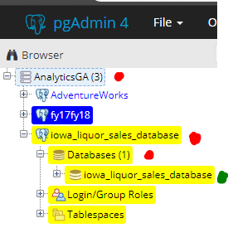

The tree structure will progress through the following layers:

* + Click “AnalyticsGA”
  + Click “iowa_liquor_sales_database”
  + Click “Databases”
  + Click “iowa_liquor_sales_database”
  + Click “Schemas”
  + Click “public”
  + Click “Tables”
  + Click “Columns”

This process reveals the specific contents of each data table.

FY17 & FY18 TABLES

* The ‘fy17’ and ‘fy18’ tables are located here:  
  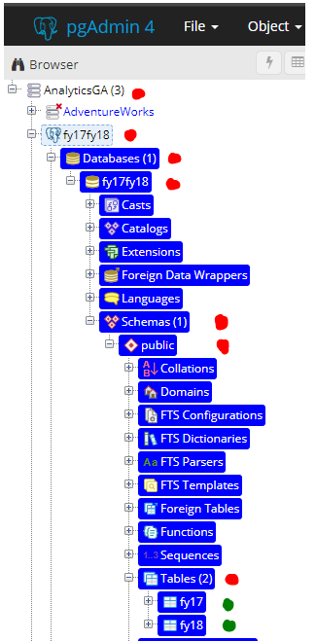
  + Click “AnalyticsGA”
  + Click “ fy17fy18 ”
  + Click “ Databases ”
  + Click “ fy17fy18 ”
    - **Note:** Right-click here and choose “Query Tool…” to run queries against the fy17 and fy18 tables.
  + Click “ Schemas ”
  + Click “ public ”
  + Click “ Tables ”
  + Click “ fy17 ” or “ fy18 ”

ADVENTUREWORKS

* The ‘adventureworks’’ database is located here:  
  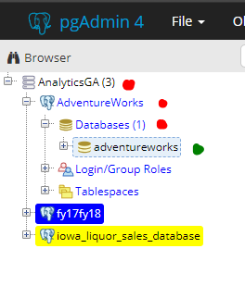
  + Click “AnalyticsGA”
  + Click “AdventureWorks”
  + Click “Databases”
  + Click “adventureworks”

# 

# 

# 

# 

# Connecting to Legacy Database

**LEGACY INSTRUCTIONS**

1. Before starting the lesson, run through installation on your machine and with your class.
2. Google “pgAdmin 4 download” and install pgAdmin 4 (materials tested on v3.3).
3. Once installed, launch pgAdmin 4 and complete the following steps:
   * 1. Right click on **Servers** in left pane and select **Create** ▶ **Server**.
     2. On the **General** tab, name the server “GA Analytics Data.”
     3. On the **Connection** tab, enter **Host** **address**:

analyticsga-psql.generalassemb.ly

* + 1. **port**: 5432 **maintenance database**: postgres
    2. **username**: analytics_student
    3. **password**: analyticsga (Check ☑ save password.)

**TROUBLESHOOTING**

If you have already had your students install PGAdmin locally, and are pointing to a SQL database that no longer exists or fails to connect, you can make the following change to get reconnected:

1. In the server list on the left hand side, right-click the server that no longer connects and select “Properties”:  
   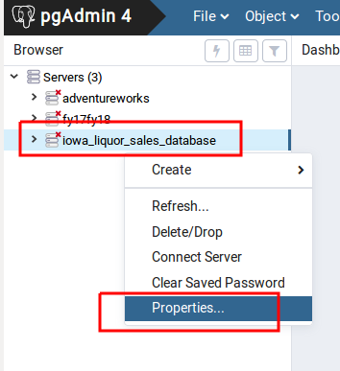
2. Under the “Connection” tab in the properties dialog, replace the contents of the “Host name/address” section with *one* of the following:  
     
   **analyticsga-psql.generalassemb.ly**  
   **Webspi-global.cvcay6fzmfvt.us-east-2.rds.amazonaws.com  
     
   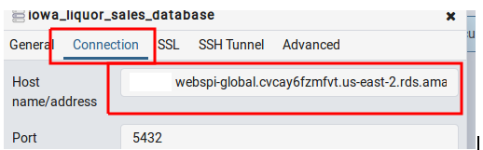**
3. Click “Save”. You can now resume use of the database as before.